Week 5 - Monday Questions

- How many actors are there with the last name ‘Wahlberg’?
2

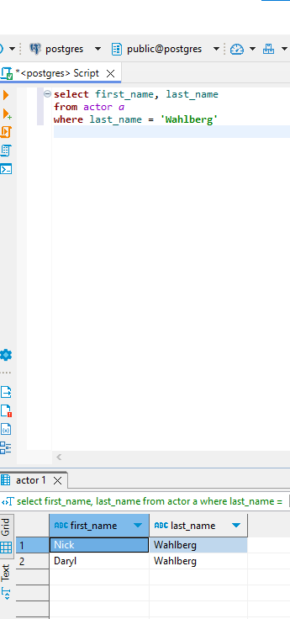

- How many payments were made between $3.99 and $5.99?

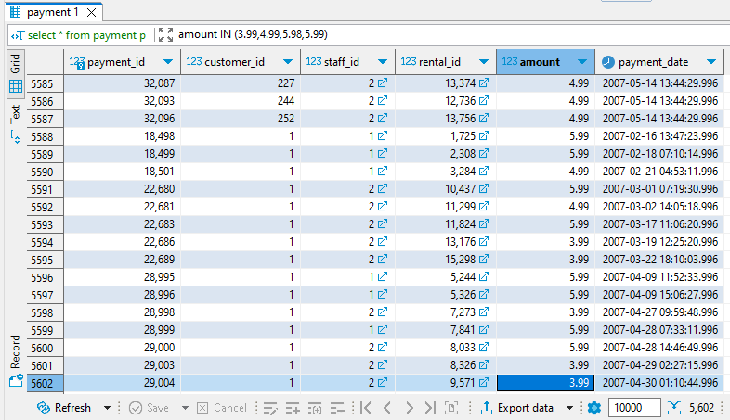
5602

- What film does the store have the most of? (search in inventory)

The answer sheet shows 200 with 9 films but the data said there were 72 films with 8 copies, 200 being one of them.

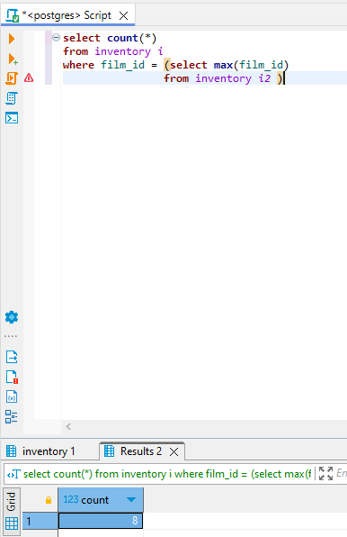

- How many customers have the last name ‘William’?

0

- What store employee (get the id) sold the most rentals?

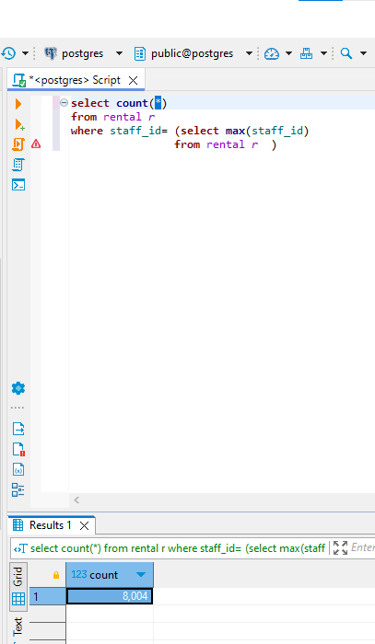

- How many different district names are there?

378

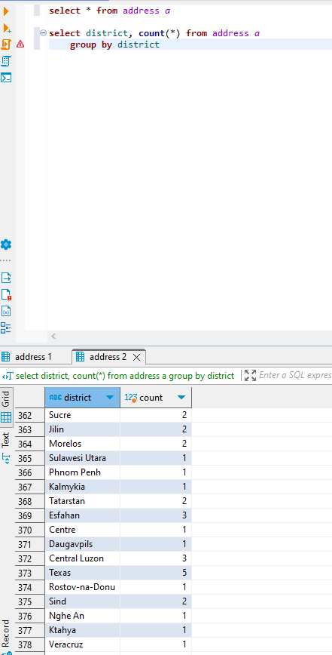
- What film has the most actors in it? (use film_actor table and get film_id)

508, 15

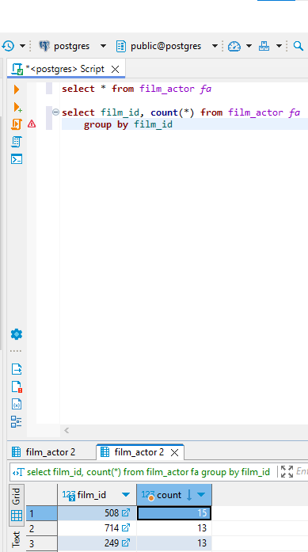

- From store_id 1, how many customers have a last name ending with ‘es’? (use customer table)

I have checked customer and Customers and neither one had any applicable data. I checked every table and none of the tables had any relevant data. I think this data has been altered/erased because in lecture 1.3 Brandon says “People have been messing with- adding to the database here” at 2 minutes in.

- How many payment amounts (4.99, 5.99, etc.) had a number of rentals above 250 for customers with ids between 380 and 430? (use group by and having > 250)

3 of them, 2.99, .99, and 4.99
Value 1 is the total count through all the payments whereas value 2 is the count for customers between 380 and 430.

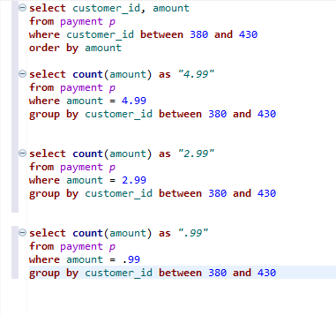

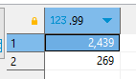

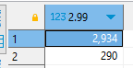

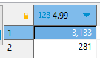

- Within the film table, how many rating categories are there? And what rating has the most movies total?
5
